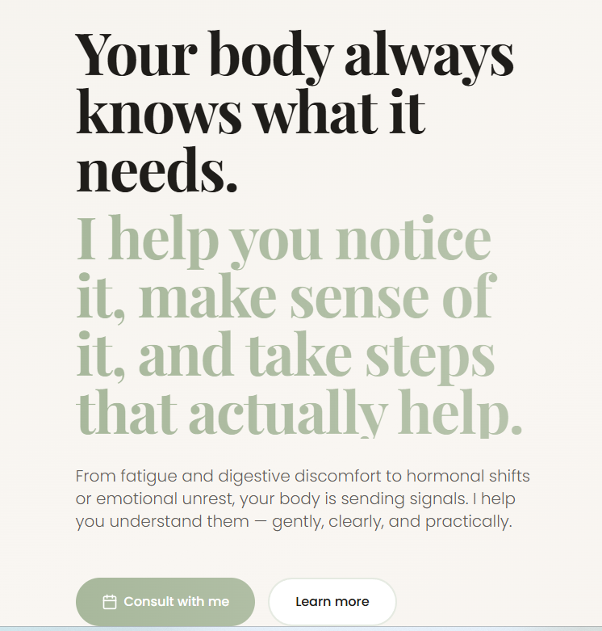

Your body already knows how to heal.
Most metabolic issues begin quietly — often in your early twenties.
Tiredness after meals, bloating, acne, irregular sleep, stubborn belly fat — they’re not random. They’re your body asking for attention.
When you start listening early, healing becomes simple and natural. I help you do that through Personalised Ayurveda
[Consult with me] [Learn more]


Home Services About Contact

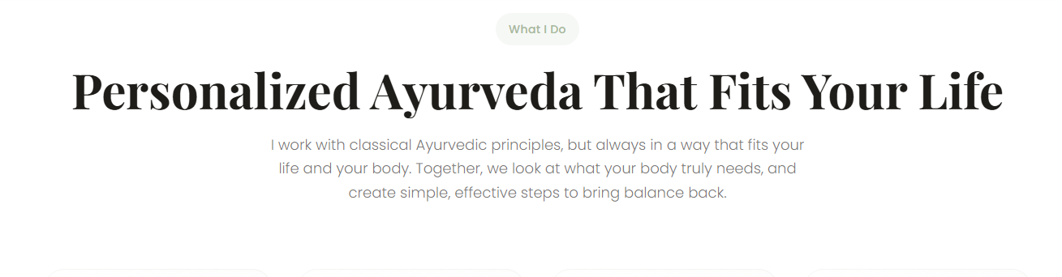
Add → that fits your “ busy “ in front of life - in the first sentence

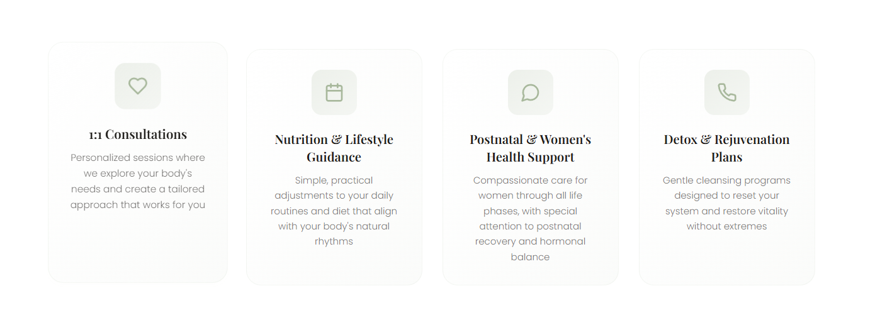

- 1: 1 online Consultations
Personalised sessions where we explore your body’s unique body constitution and create a tailored treatment plan that works for you.

- Nutrition and Lifestyle Guidance
Simple, practical adjustments to your daily routines and personalised dietary recommendations

- Remove post natal and retain Women’s health support
Compassionate care for women with special attention to hormonal imbalances

- Detox & Rejuvenation Plan
Gentle gut cleansing programs for general wellness as a reset to the modern life

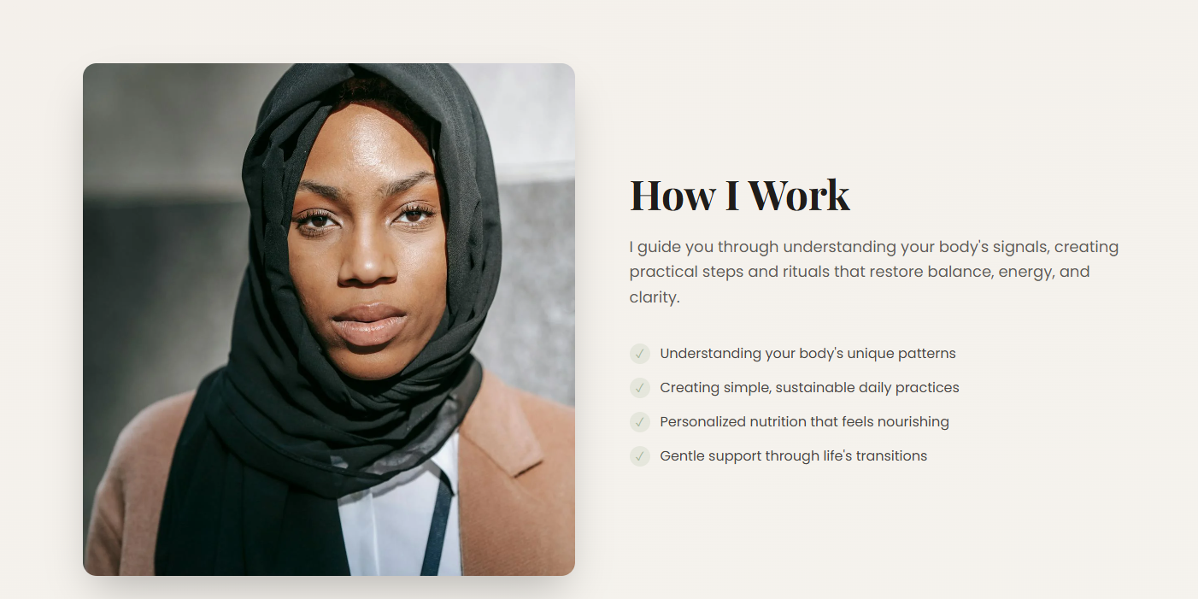

How I work

I look closely at your symptoms, history, and blood work to understand the deeper cause of your condition.
Then I create an Ayurvedic treatment plan tailored to your body’s current state.

In the bullet points : -
Keep all,
Change the 3 rd one to personalised dietary guidelines

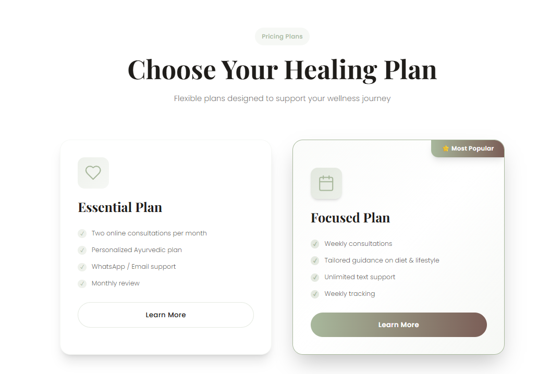

Keep the content as such

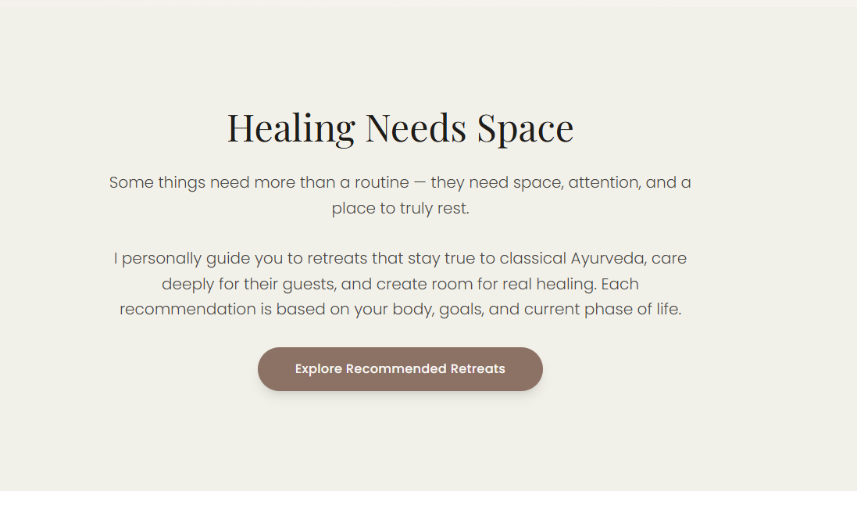

Arrange this after the healing plan

Headline
Healing Needs Space

Subtext
Some things don’t improve with quick fixes.
They need attention, clarity, and the right environment to heal.

Body
Food and lifestyle help a lot, but not always enough.
Certain conditions need structured treatment or the comfort of an in-patient setting to truly improve.
During a consultation, I understand what your body is going through — the symptoms, the patterns, the stress behind them.
From there, I guide you toward the treatment plan, the number of days you may need, and the ideal place that fits your health goals and budget.
Healing feels different when it’s tailored for you.

CTA Button
Book an Appointment

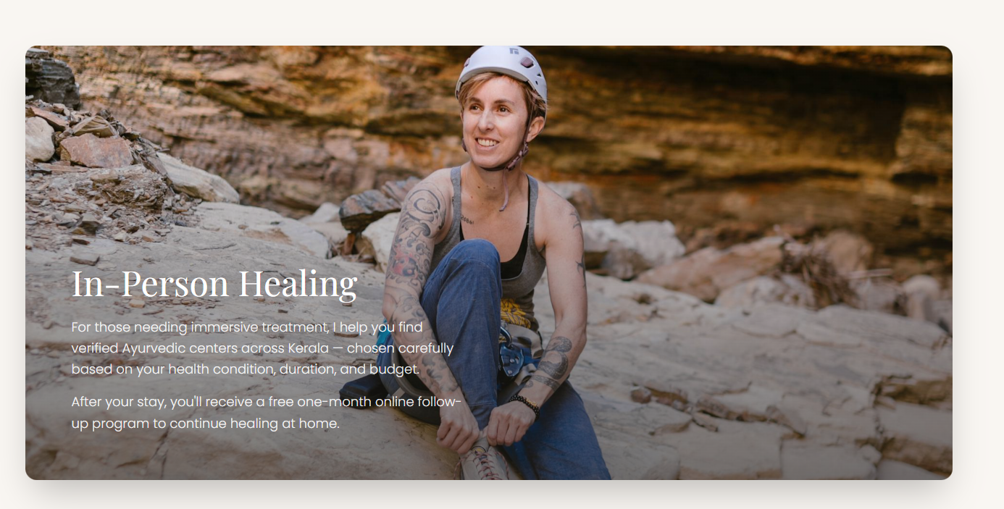
Make the CTA inside the picture

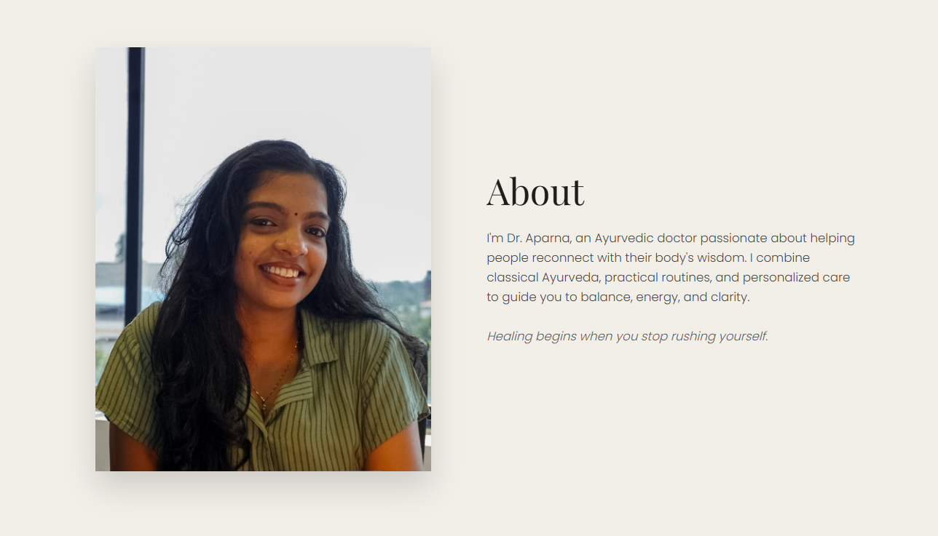

About (Refined Copy)

I’m Dr. Aparna, an Ayurvedic doctor trained in genomic technologies.
I work by understanding your unique body and mind, and bringing forward the authentic Kerala Ayurveda I grew up around — in a way that fits into real, busy lives.

I prefer gentle, plant-based medicines over stronger mineral preparations, and I focus on lifestyle, diet, and classical Ayurvedic treatment that supports your body without overwhelming it.
Real change begins when your body is given time and the right guidance.



Write to me to whatsapp

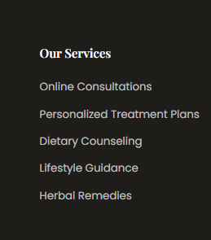

Services

Change herbal remedies to ayurveda medicines
Add retreat suggestions

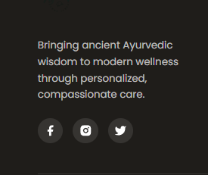

Add youtube icon instead of twitter

Insta : https://www.instagram.com/theayurvedadoc?igsh=aGI2MmNtajdmMzU4

Youtube : https://youtube.com/@draparnaalbert?si=ePndamK_BltreL0X

Facebook : https://www.facebook.com/share/1BsoBKrYds/

